Jenkins + Docker + Playwright

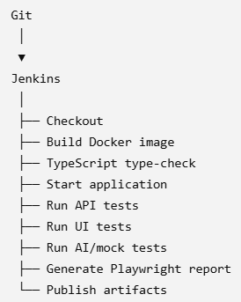
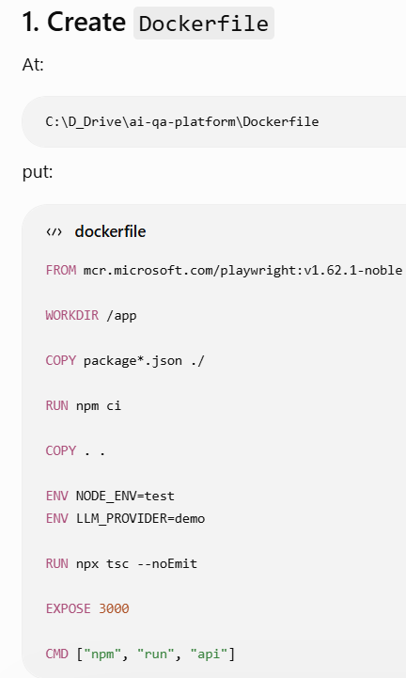
This gives Jenkins a container containing:
- Node.js
- npm
- Playwright
- Chromium
- Firefox
- WebKit
- your application
- your dependencies
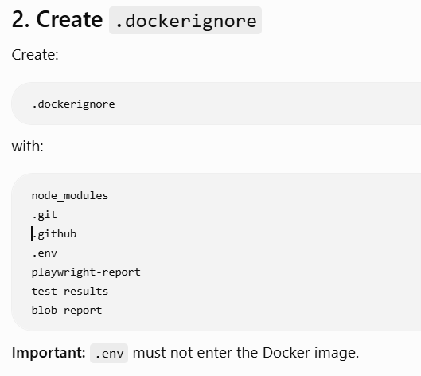
3. Make sure your package scripts exist
Your package.json should have something similar to:
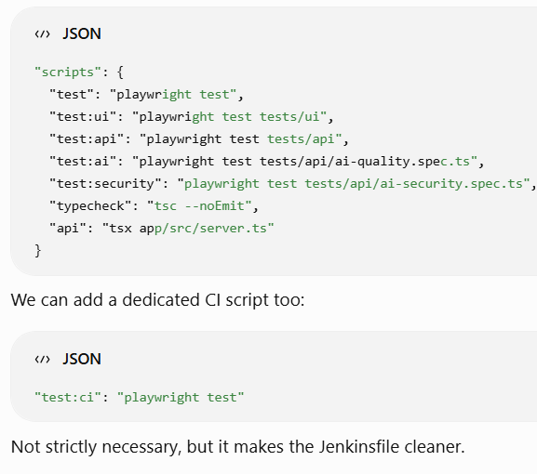
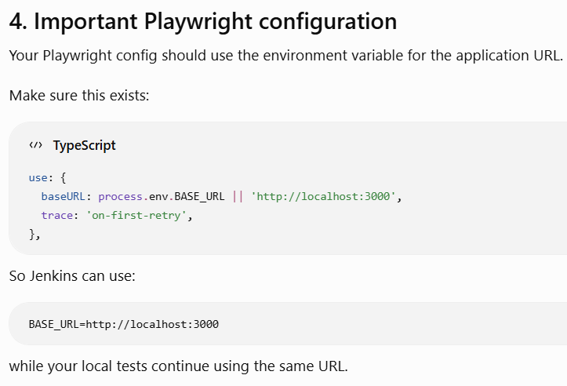
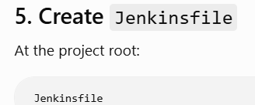
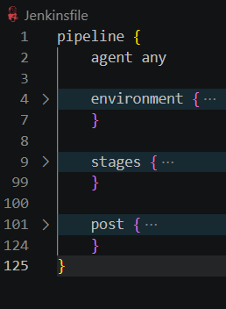
environment {
BASE_URL = 'http://localhost:3000'
LLM_PROVIDER = 'demo'
}
stages {

stage('Checkout') {
steps {
checkout scm
}
}

stage('Build Docker Image') {
steps {
sh 'docker build -t ai-qa-platform:${BUILD_NUMBER} .'
}
}

stage('Type Check') {
steps {
sh '''
docker run --rm \
-e LLM_PROVIDER=${LLM_PROVIDER} \
ai-qa-platform:${BUILD_NUMBER} \
npm run typecheck
'''
}
}

stage('Start Application') {
steps {
sh '''
docker rm -f ai-qa-platform-${BUILD_NUMBER} || true

docker run -d \
--name ai-qa-platform-${BUILD_NUMBER} \
-e LLM_PROVIDER=${LLM_PROVIDER} \
-p 3000:3000 \
ai-qa-platform:${BUILD_NUMBER}
'''
}
}

stage('API Tests') {
steps {
sh '''
docker run --rm \
--network host \
-e BASE_URL=${BASE_URL} \
-e LLM_PROVIDER=${LLM_PROVIDER} \
ai-qa-platform:${BUILD_NUMBER} \
npm run test:api
'''
}
}

stage('AI Tests') {
steps {
sh '''
docker run --rm \
--network host \
-e BASE_URL=${BASE_URL} \
-e LLM_PROVIDER=${LLM_PROVIDER} \
ai-qa-platform:${BUILD_NUMBER} \
npm run test:ai
'''
}
}

stage('Security Tests') {
steps {
sh '''
docker run --rm \
--network host \
-e BASE_URL=${BASE_URL} \
-e LLM_PROVIDER=${LLM_PROVIDER} \
ai-qa-platform:${BUILD_NUMBER} \
npm run test:security
'''
}
}

stage('UI Tests') {
steps {
sh '''
docker run --rm \
--network host \
-e BASE_URL=${BASE_URL} \
-e LLM_PROVIDER=${LLM_PROVIDER} \
ai-qa-platform:${BUILD_NUMBER} \
npm run test:ui
'''
}
}
}

